**Smart Lender Loan Approval Using Machine Learning**

Loans are like financial tools that allow people and businesses to borrow money, which they must then repay over time, usually with some extra money added as interest. There are many types of loans out there, like personal loans, mortgages, car loans, student loans, and business loans. These loans are offered by banks, credit unions, and other financial institutions, each with its own unique rules and requirements. Things like interest rates, how long you have to pay the loan back, and any additional charges can all be different depending on the lender and the specific type of loan.

Now, let's focus on personal loans. Think of them as a flexible way to borrow money without needing to put up any collateral. People use personal loans for all sorts of things, like fixing up their homes, covering medical bills, or consolidating their debts. How much money you can borrow, the interest rate you'll be charged, and how long you have to repay the loan will depend on where you get the loan and how trustworthy you appear to the lender. Generally, to get a personal loan, yo need to show that you have a regular income and a good credit history.

Now, here's where it gets interesting. Machine learning, a type of computer technology, can be used to predict whether someone will be approved for a personal loan. It does this by crunching numbers and analyzing the person's financial info and credit history. This helps banks and other money-lending places make smarter choices about which loan applications they should say "yes" to and which ones they should turn down. So, in a nutshell, it's a bit like having a virtual financial expert to help decide who should get a personal loan and who shouldn't.

**Technical Architecture**:

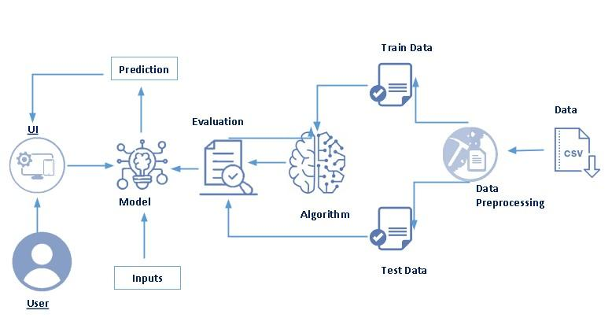

**Project Flow:**

● User interacts with the UI to enter the input.

● Entered input is analysed by the model which is integrated.

● Once model analyses the input the prediction is showcased on the UI

To accomplish this, we have to complete all the activities listed below

● Define Problem / Problem Understanding

○ Specify the business problem

○ Business requirements

○ Literature Survey

○ Social or Business Impact.

● Data Collection & Preparation

○ Collect the dataset

○ Data Preparation

● Exploratory Data Analysis

○ Descriptive statistical

○ Visual Analysis

● Model Building

○ Training the model in multiple algorithms

○ Testing the model

● Performance Testing & Hyperparameter Tuning

○ Testing model with multiple evaluation metrics

○ Comparing model accuracy before & after applying hyperparameter tuning

● Model Deployment

○ Save the best model

○ Integrate with Web Framework

● Project Demonstration & Documentation

○ Record explanation Video for project end to end solution

○ Project Documentation-Step by step project development procedure

**Project Structure:**

Create the Project folder which contains files as shown below

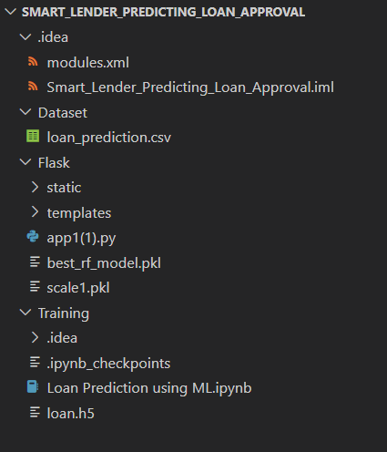

● We are building a flask application which needs HTML pages stored in the templates folder and a python script app.py for scripting.

● rdf.pkl is our saved model. Further we will use this model for flask integration.

● Training folder contains a model training file.

**Milestone 1: Define Problem / Problem Understanding**

**Activity 1: Specify the business problem**

Refer Project Description

**Activity 2: Business requirements**

The business requirements for a machine learning model to predict Smart lender predicting loan approval include the ability to accurately predict loan approval based on applicant information,Minimise the number of false positives (approved loans that default) and false negatives(rejected loans that would have been successful).Provide an explanation for the model's decision, to comply with regulations and improve transparency.

**Activity 3: Literature Survey**

As the data is increasing daily due to digitization in the banking sector, people want to apply

for loans through the internet. Machine Learning (ML), as a typical method for information

investigation, has gotten more consideration increasingly. Individuals of various businesses

are utilising ML calculations to take care of the issues dependent on their industry

information. Banks are facing a significant problem in the approval of the loan. Daily there are

so many applications that are challenging to manage by the bank employees, and also the

chances of some mistakes are high.Most banks earn profit from the loan, but it is risky to

choose deserving customers from the number of applications.There are various algorithms

that have been used with varying levels of success. Logistic regression, decision tree,

random forest, and neural networks have all been used and have been able to accurately

predict loan defaults. Commonly used features in these studies include credit score, income,

and employment history, sometimes also other features like age, occupation, and education

level.

**Activity 4: Social or Business Impact.**

Social Impact :- Personal loans can stimulate economic growth by providing individuals

with the funds they need to make major purchases, start businesses, or invest in their

Education

Business Model/Impact :- Personal loan providers may charge fees for services such as

loan origination, processing, and late payments.Advertising the brand awareness and

marketing to reach out to potential borrowers to generate revenue.

**Milestone 2: Data Collection & Preparation**

ML depends heavily on data. It is the most crucial aspect that makes algorithm training possible. So this

section allows you to download the required dataset.

**Activity 1: Collect the dataset**

There are many popular open sources for collecting the data. Eg: kaggle.com, UCI

repository, etc.In this project we have used .csv data. This data is downloaded from kaggle.com. Please refer to the link given below to download the dataset.

Link: https://www.kaggle.com/datasets/altruistdelhite04/loan-prediction-problem-dataset

As the dataset is downloaded. Let us read and understand the data properly with the help of some visualisation techniques and some analysing techniques.

Note: There are a number of techniques for understanding the data. But here we have

used some of it. In an additional way, you can use multiple techniques.

**Activity 1.1: Importing the libraries**

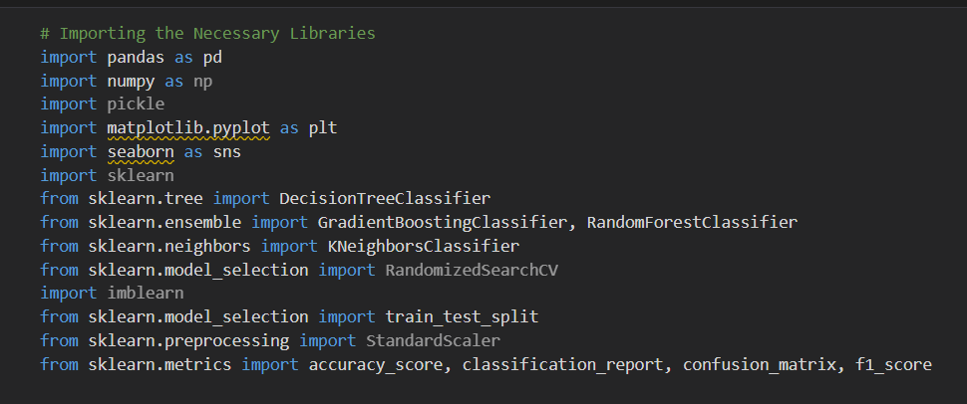

**Activity 1.2: Read the Dataset**

Our dataset format might be in .csv, excel files, .txt, .json, etc. We can read the dataset

with the help of pandas.

In pandas we have a function called read_csv() to read the dataset. As a parameter we

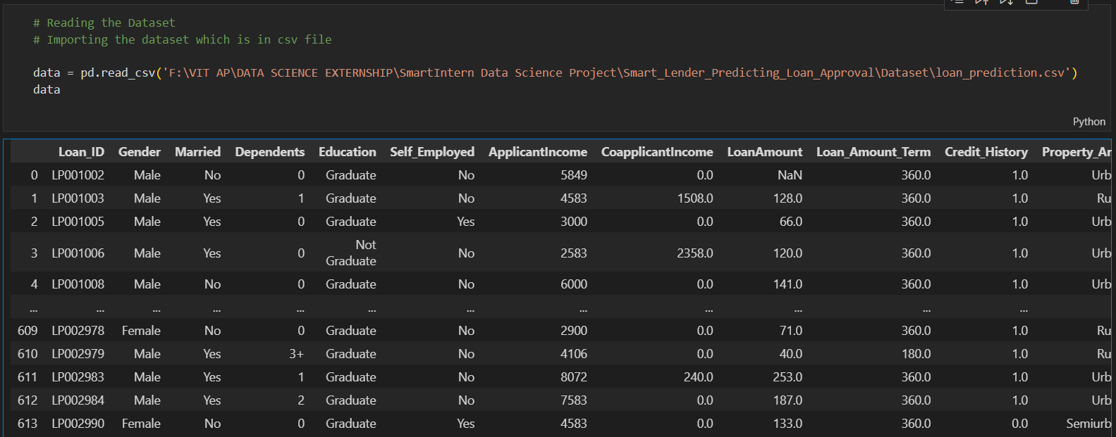have to give the directory of the csv file.

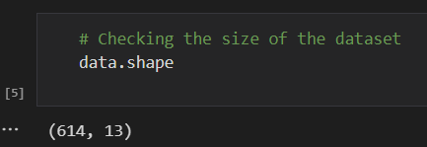

**Activity 2: Data Preparation**

As we have understood how the data is, let's pre-process the collected data.

The download data set is not suitable for training the machine learning model as it might

have so much randomness so we need to clean the dataset properly in order to fetch good

results. This activity includes the following steps.

● Handling missing values

● Handling categorical data

● Handling Imbalance Data

Note: These are the general steps of pre-processing the data before using it for machine

learning. Depending on the condition of your dataset, you may or may not have to go

through all these steps.

**Activity 2.1: Handling missing values**

**●**  Let’s find the shape of our dataset first. To find the shape of our data, the df.shape

method is used. To find the data type, df.info() function is used.

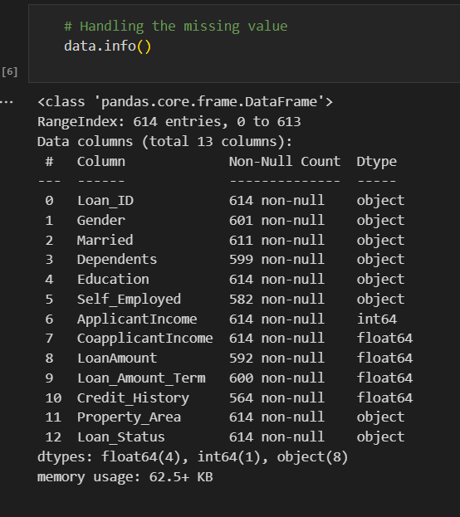

● For checking the null values, df.isnull() function is used. To sum those null

values we use .sum() function. From the below image we found that there are

no null values present in our dataset. So we can skip handling the missing

values step.

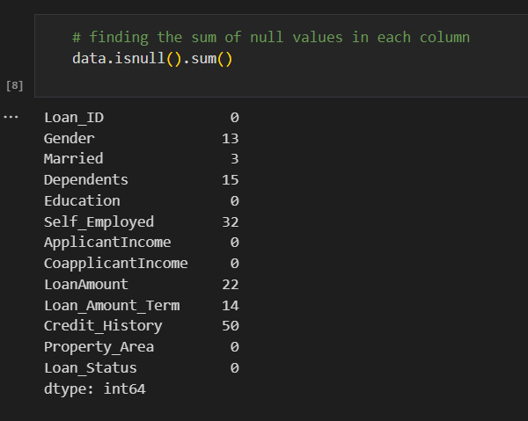

● From the above code of analysis, we can infer that columns such as

gender ,married,dependents,self employed ,loan amount, loan amount

term and credit history are having the missing values, we need to treat

them in a required way.

● We will fill in the missing values in the numeric data type using the mean

value of that particular column and categorical data type using the most

repeated value

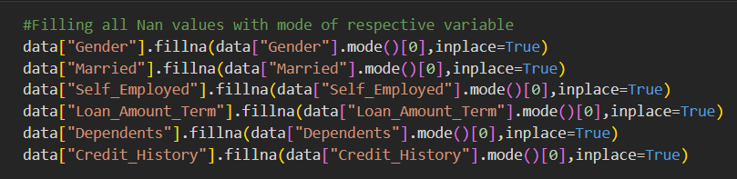

**Activity 2.2: Handling Categorical Values**

As we can see our dataset has categorical data we must convert the categorical data to

integer encoding or binary encoding.

To convert the categorical features into numerical features we use encoding techniques.

There are several techniques but in our project we are using manual encoding with the

help of list comprehension.

● In our project, Gender ,married,dependents,self-employed,co-applicants

income,loan amount ,loan amount term, credit history With list comprehension

encoding is done.

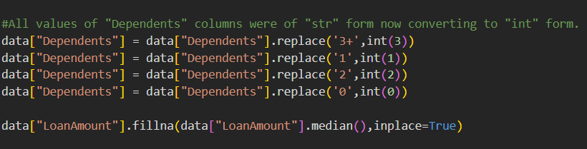

**Activity 2.3:Handling Imbalance Data**

Data Balancing is one of the most important step, which need to be performed for

classification models, because when we train our model on imbalanced dataset ,we will

get biassed results, which means our model is able to predict only one class element

For Balancing the data we are using the SMOTE Method.

SMOTE: Synthetic minority over sampling technique, which will create new synthetic data

points for under class as per the requirements given by us using KNN method.

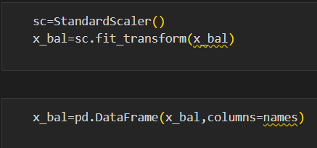

**Milestone 3: Exploratory Data Analysis**

**Activity 1: Descriptive statistical**

Descriptive analysis is to study the basic features of data with the statistical process. Here

pandas has a worthy function called describe. With this describe function we can

understand the unique, top and frequent values of categorical features. And we can find

mean, std, min, max and percentile values of continuous features.

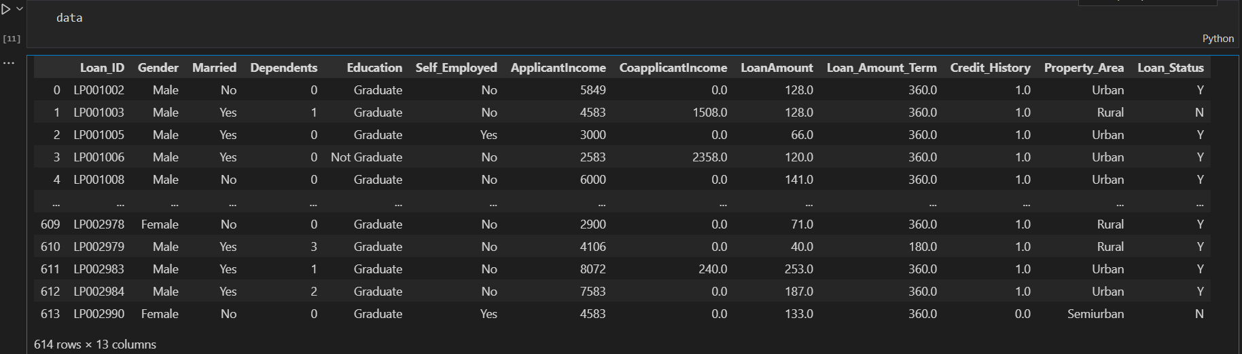

**Activity 2: Visual analysis**

Visual analysis is the process of using visual representations, such as charts, plots, and

graphs, to explore and understand data. It is a way to quickly identify patterns, trends, and

outliers in the data, which can help to gain insights and make informed decisions.

**Activity 2.1: Univariate analysis**

In simple words, univariate analysis is understanding the data with a single feature. Here

we have displayed two different graphs such as distplot and countplot.

● The Seaborn package provides a wonderful function distplot. With the help of

distplot, we can find the distribution of the feature. To make multiple graphs in a

single plot, we use subplot.

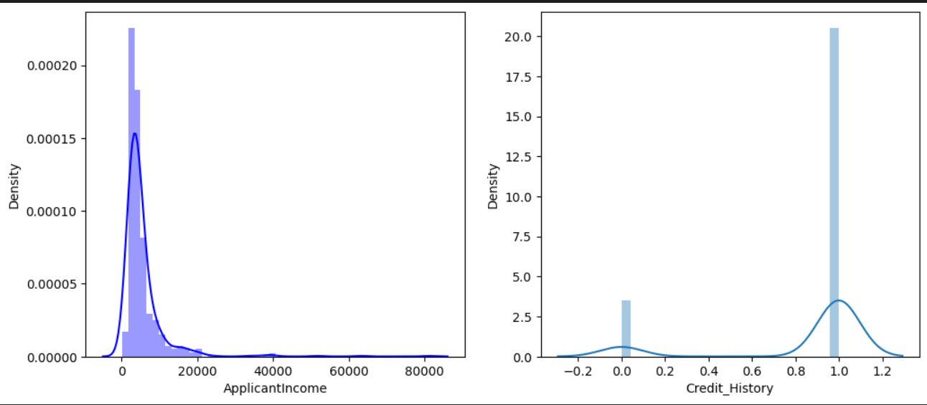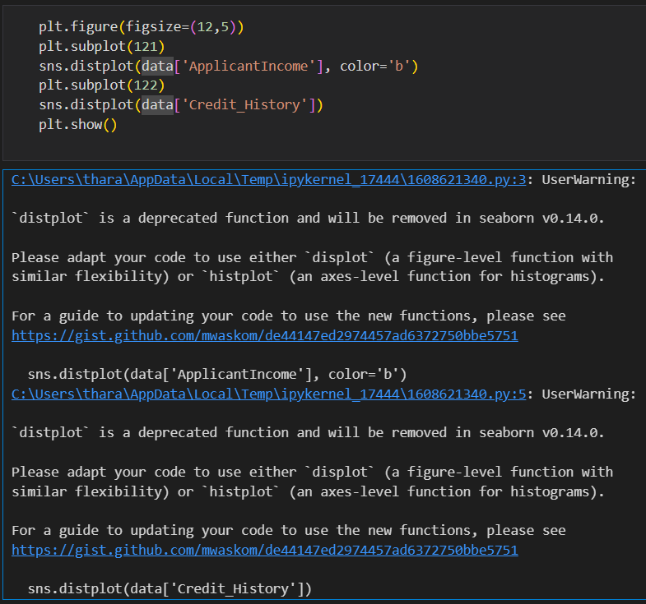

● In our dataset we have some categorical features. With the count plot function, we

are going to count the unique category in those features. We have created a

dummy data frame with categorical features. With for loop and subplot we have

plotted this below graph.

● From the plot we came to know, Applicants income is skewed towards left side,

where as credit history is categorical with 1.0 and 0.0

### Countplot:-

A count plot can be thought of as a histogram across a categorical, instead of quantitative, variable. The basic API and options are identical to those for barplot() , so you can compare counts across nested variables.

From the graph we can infer that , gender and education is a categorical variables with 2 categories , from gender column we can infer that 0-category is having more weightage than category-1,while education with 0,it means no education is a underclass when compared with category -1, which means educated

## Activity 2.2: Bivariate analysis

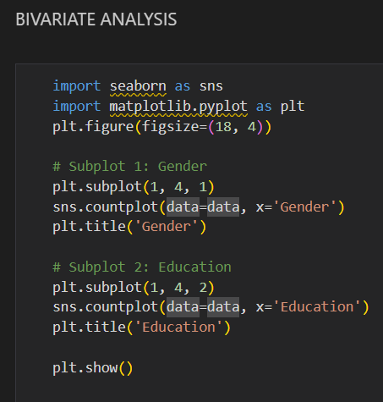

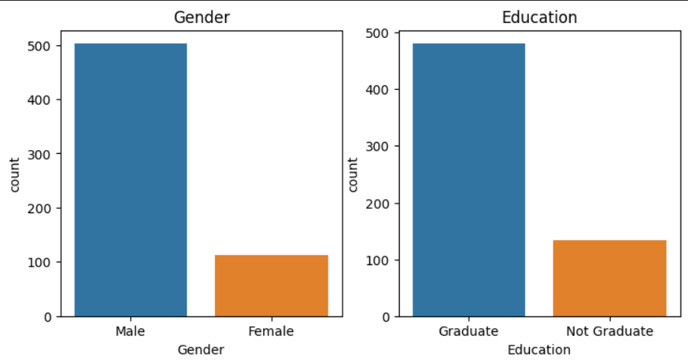

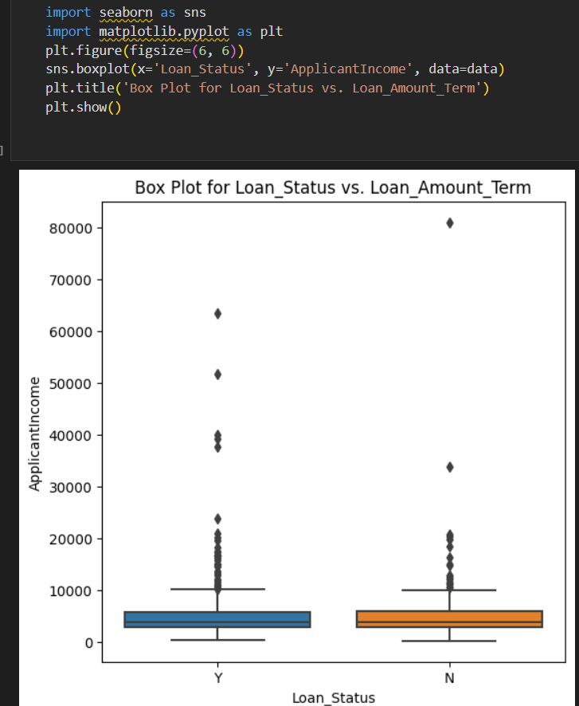

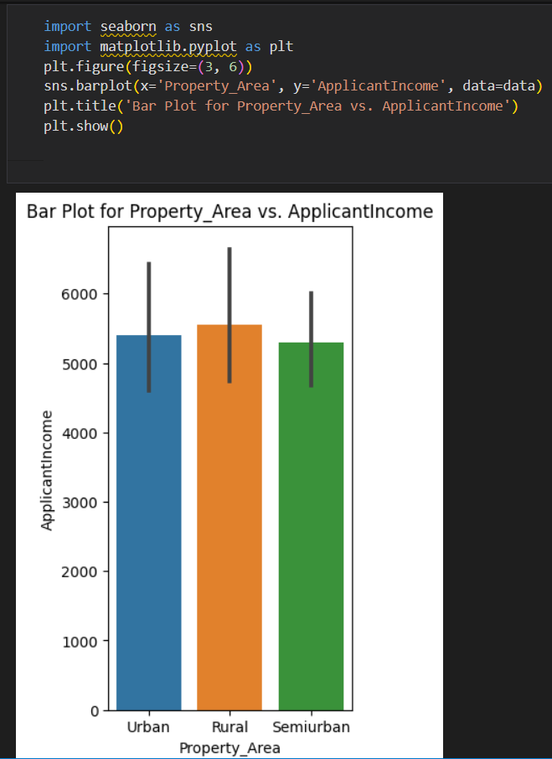

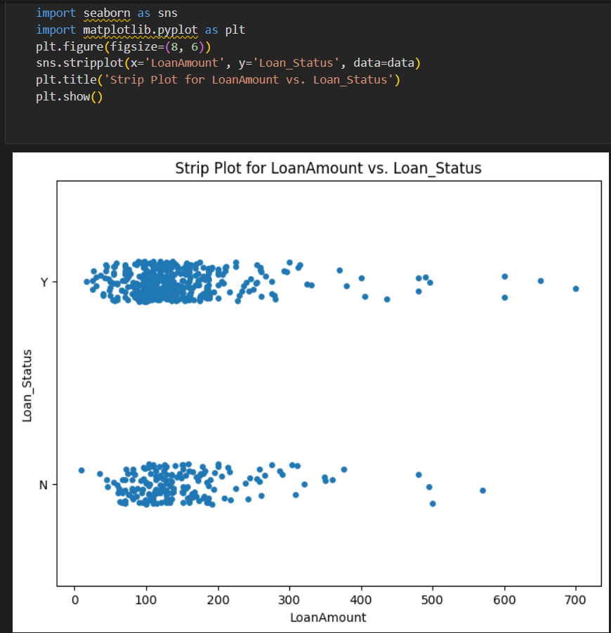

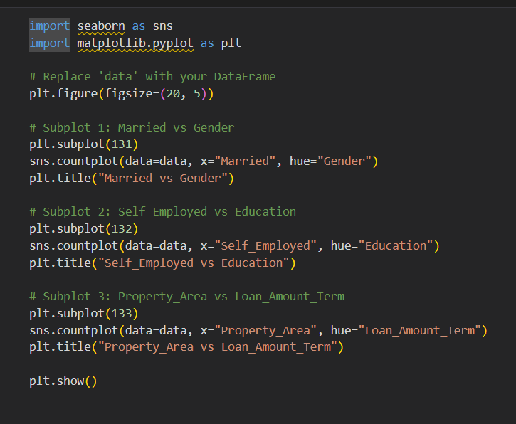

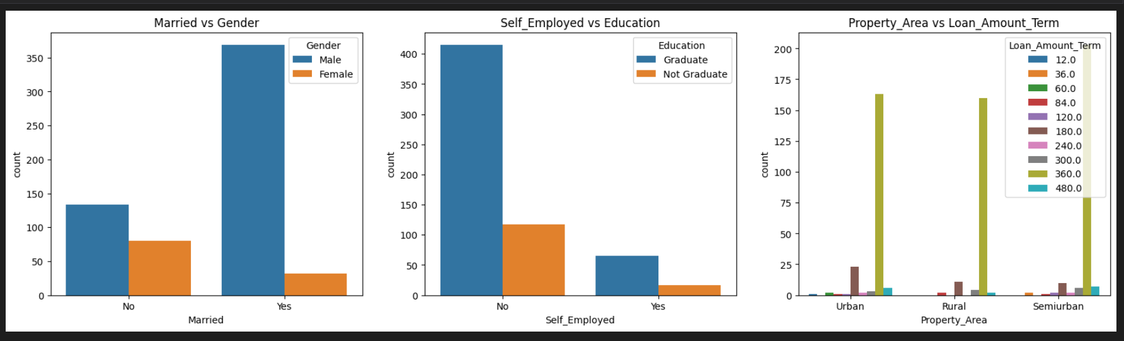

From the above graph we can infer the analysis such as

* Segmenting the gender column and married column based on bar graphs
* Segmenting the Education and Self-employed based on bar graphs ,for drawing insights such as educated people are employed.
* Loan amount term based on the property area of a person holding

## Activity 2.3: Multivariate analysis

In simple words, multivariate analysis is to find the relation between multiple features. Here we have used a swarm plot from the seaborn package.

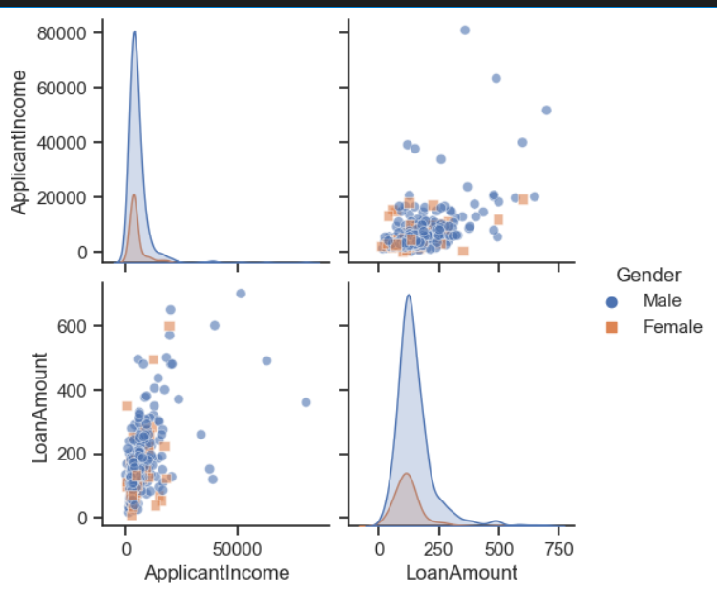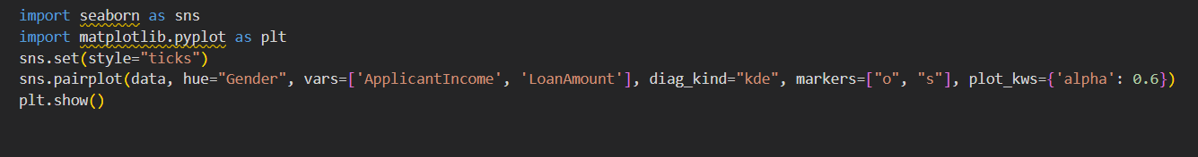

.

From the above graph we are plotting the relationship between the Gender, applicants income and loan status of the person.

Now, the code would be normalising the data by scaling it to have a similar range of values, and then splitting that data into a training set and a test set for training the model and testing its performance, respectively.

### Scaling the Data

Scaling is one the important process, we have to perform on the dataset, because of data measures in different ranges can leads to mislead in prediction

Models such as KNN, Logistic regression need scaled data, as they follow distance based method and Gradient Descent concept

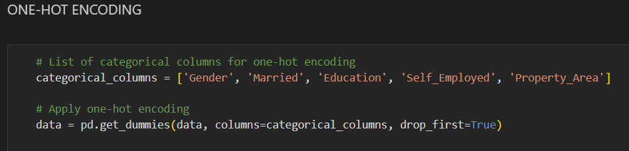.

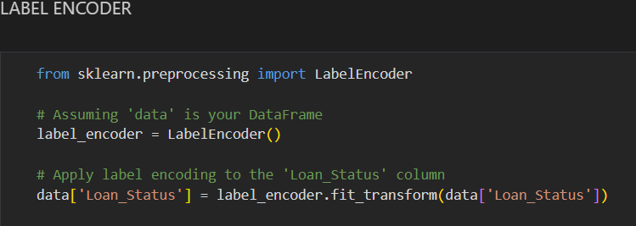

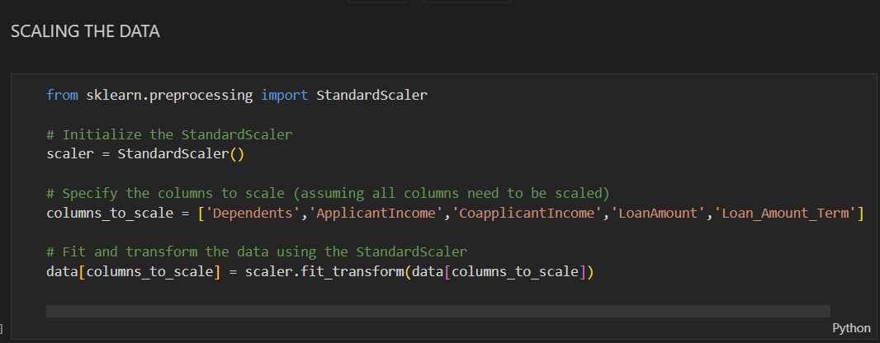

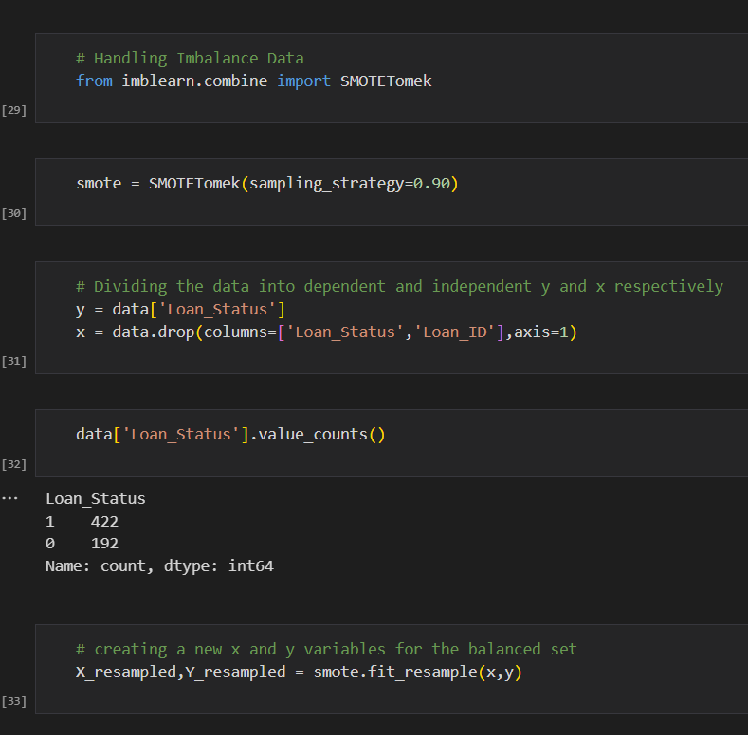

### Splitting data into train and test

Now let’s split the Dataset into train and test sets

Changes: first split the dataset into x and y and then split the data set

Here x and y variables are created. On x variable, df is passed with dropping the target variable. And on y target variable is passed. For splitting training and testing data we are using the train_test_split() function from sklearn. As parameters, we are passing x, y, test_size, random_state.

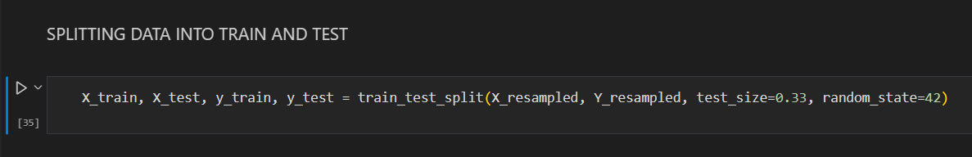

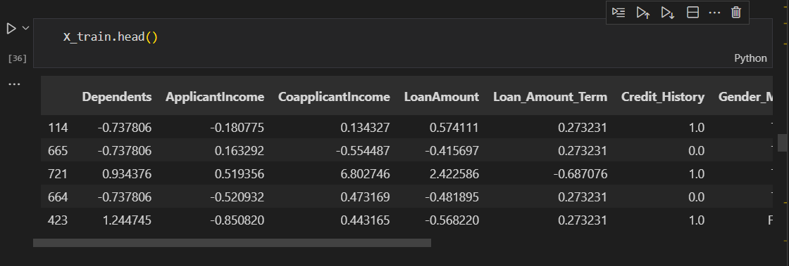

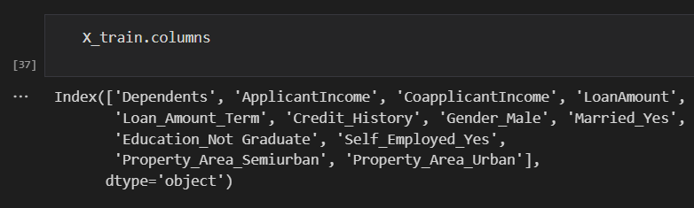

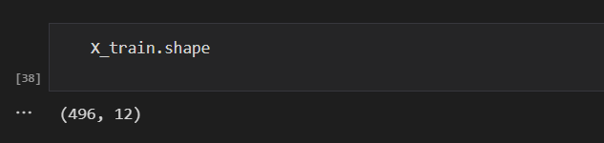

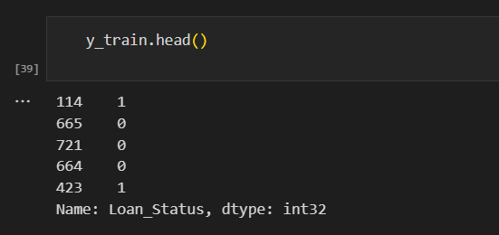

# Milestone 4: Model Building

## Activity 1: Training the model in multiple algorithms

Now our data is cleaned and it’s time to build the model. We can train our data on different algorithms. For this project we are applying four classification algorithms. The best model is saved based on its performance.

## Activity 1.1: Decision tree model

A function named decisionTree is created and train and test data are passed as the parameters. Inside the function, DecisionTreeClassifier algorithm is initialised and training data is passed to the model with the .fit() function. Test data is predicted with .predict() function and saved in a new variable. For evaluating the model, a confusion matrix and classification report is done.

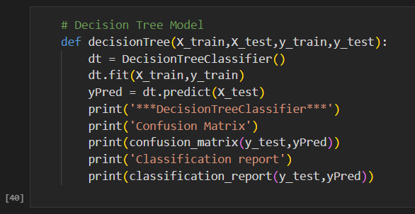

## Activity 1.2: Random forest model

A function named randomForest is created and train and test data are passed as the parameters. Inside the function, RandomForestClassifier algorithm is initialised and training data is passed to the model with .fit() function. Test data is predicted with .predict() function and saved in a new variable. For evaluating the model, a confusion matrix and classification report is done.

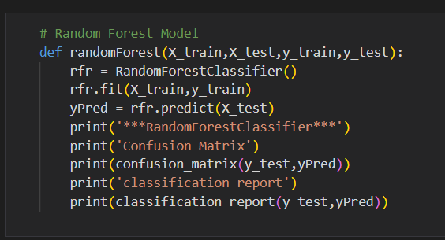

## Activity 1.3: KNN model

A function named KNN is created and train and test data are passed as the parameters. Inside the function, KNeighborsClassifier algorithm is initialised and training data is passed to the model with .fit() function. Test data is predicted with .predict() function and saved in new variable. For evaluating the model, confusion matrix and classification report is done.

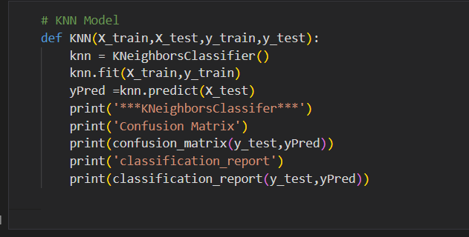

## Activity 1.4: Xgboost model

A function named xgboost is created and train and test data are passed as the parameters. Inside the function, GradientBoostingClassifier algorithm is initialised and training data is passed to the model with .fit() function. Test data is predicted with .predict() function and saved in new variable. For evaluating the model, confusion matrix and classification report is done.

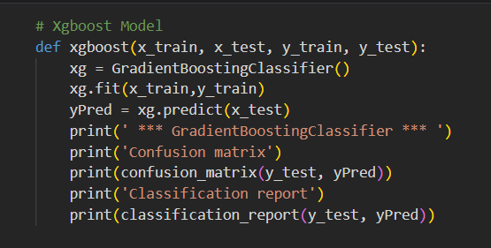

## Activity 1.5: ANN model

Building and training an Artificial Neural Network (ANN) using the Keras library with TensorFlow as the backend. The ANN is initialised as an instance of the Sequential class, which is a linear stack of layers. Then, the input layer and two hidden layers are added to the model using the Dense class, where the number of units and activation function are specified. The output layer is also added using the Dense class with a sigmoid activation function. The model is then compiled with the Adam optimizer, binary cross-entropy loss function, and accuracy metric. Finally, the model is fit to the training data with a batch size of 100, 20% validation split, and 100 epochs.

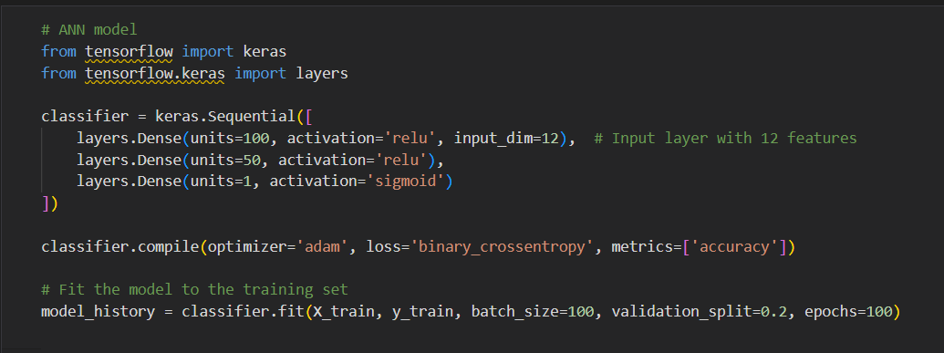

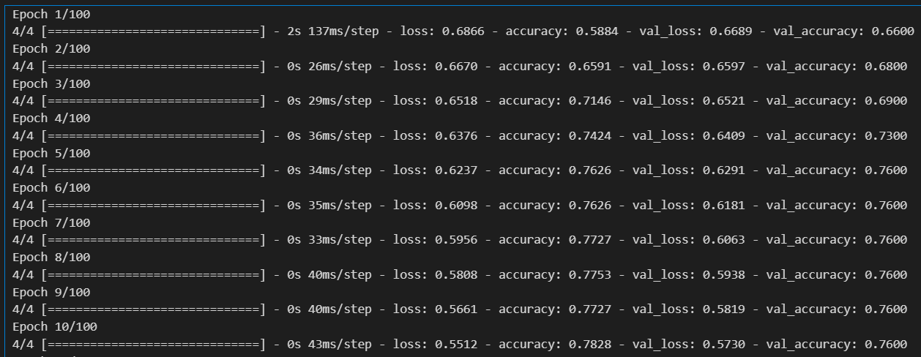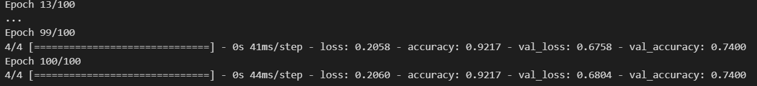

## Activity 2: Testing the model

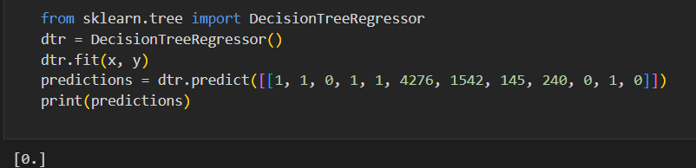

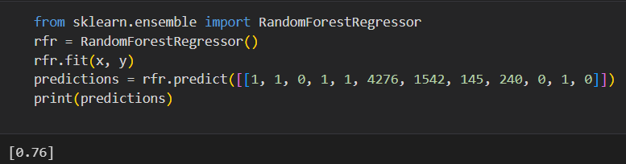

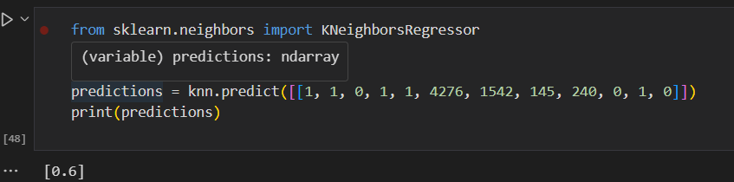

In ANN we first have to save the model to the test the inputs

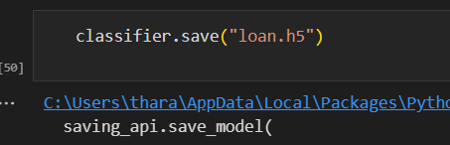

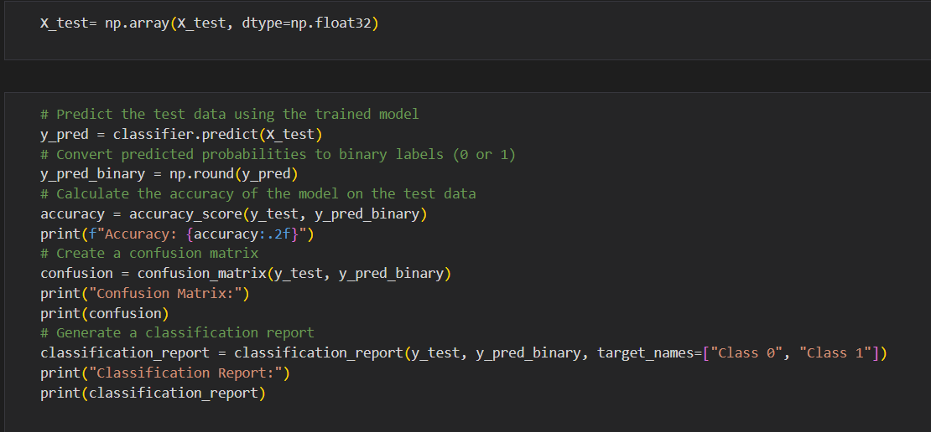

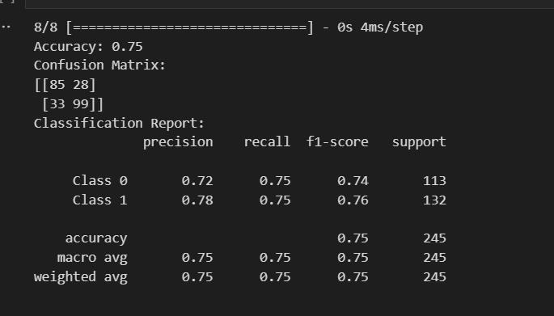

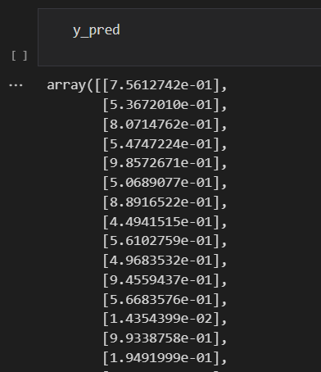

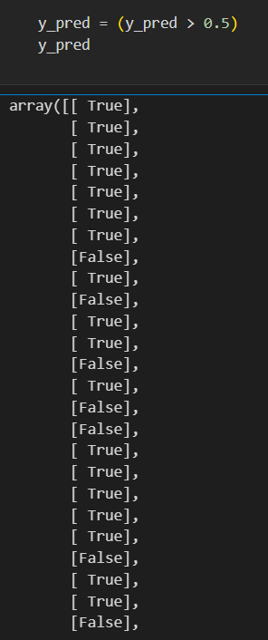

This code defines a function named "predict_exit" which takes in a sample_value as an input. The function then converts the input sample_value from a list to a numpy array. It reshapes the sample_value array as it contains only one record. Then, it applies feature scaling to the reshaped sample_value array using a scaler object 'sc' that should have been previously defined and fitted. Finally, the function returns the prediction of the classifier on the scaled sample_value.

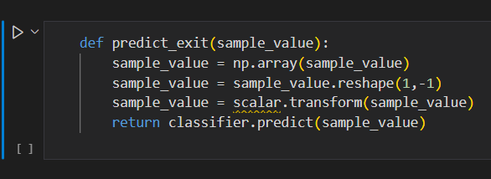

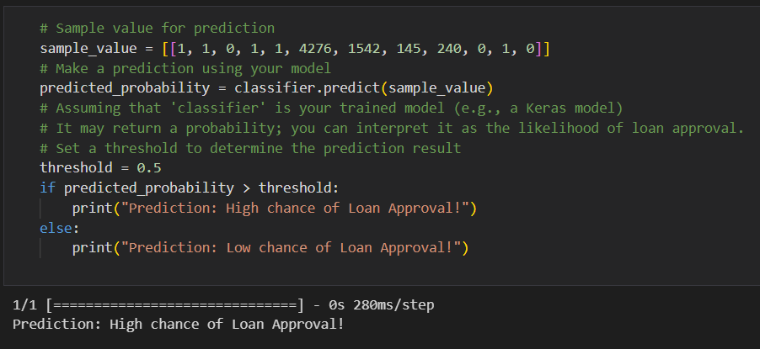

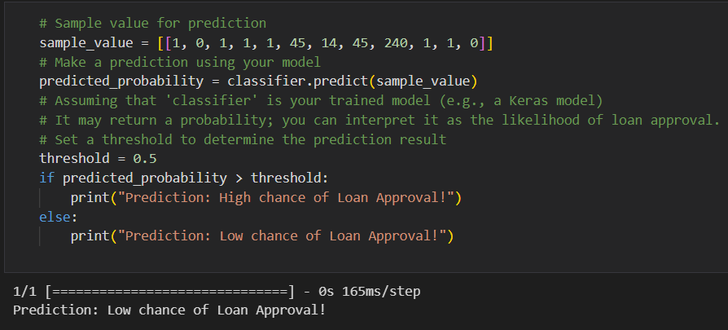

# Milestone 5: Performance Testing & Hyperparameter Tuning

## Activity 1: Testing model with multiple evaluation metrics

Multiple evaluation metrics means evaluating the model's performance on a test set using different performance measures. This can provide a more comprehensive understanding of the model's strengths and weaknesses. We are using evaluation metrics for classification tasks including accuracy, precision, recall, support and F1-score.

## Activity 1.1: Compare the model

For comparing the above four models, the compareModel function is defined.

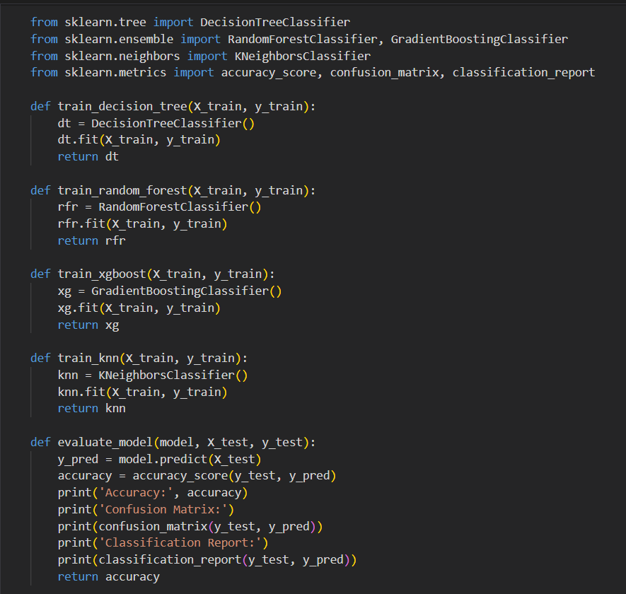

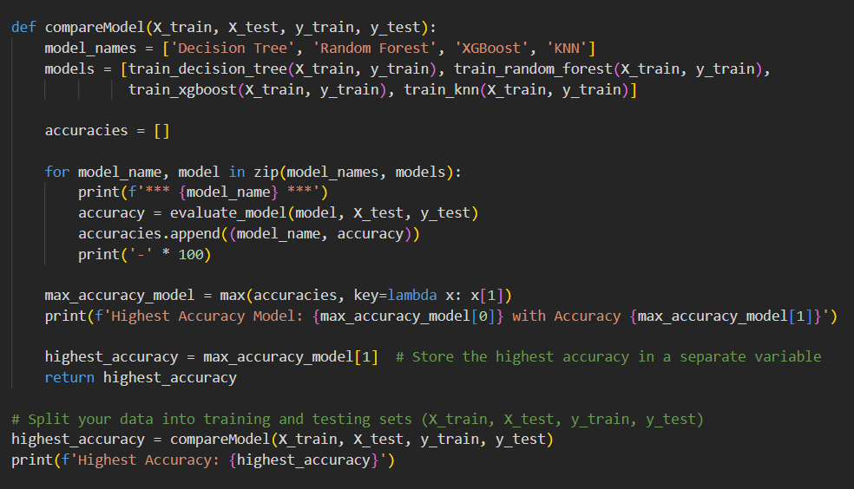

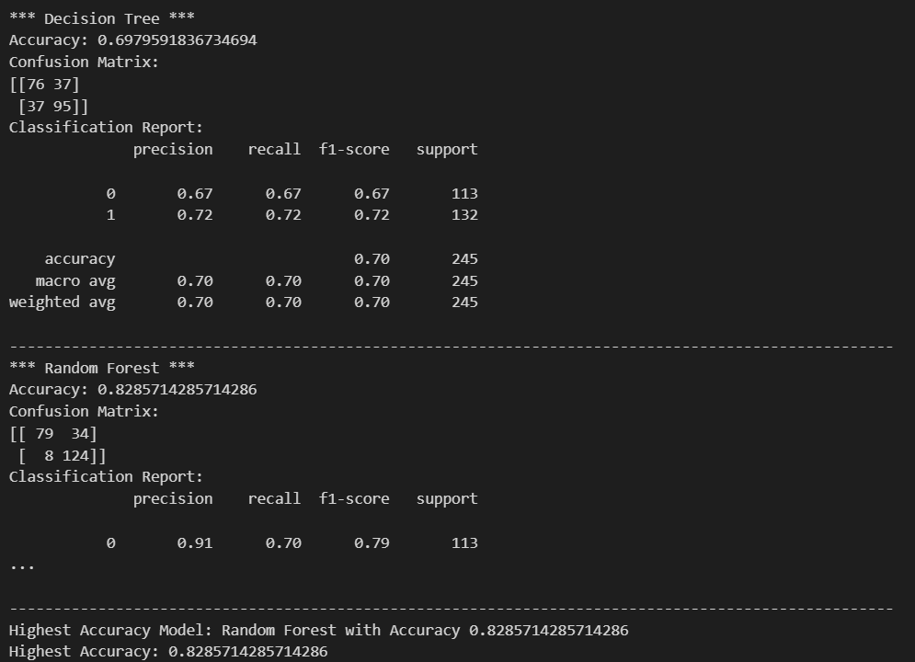

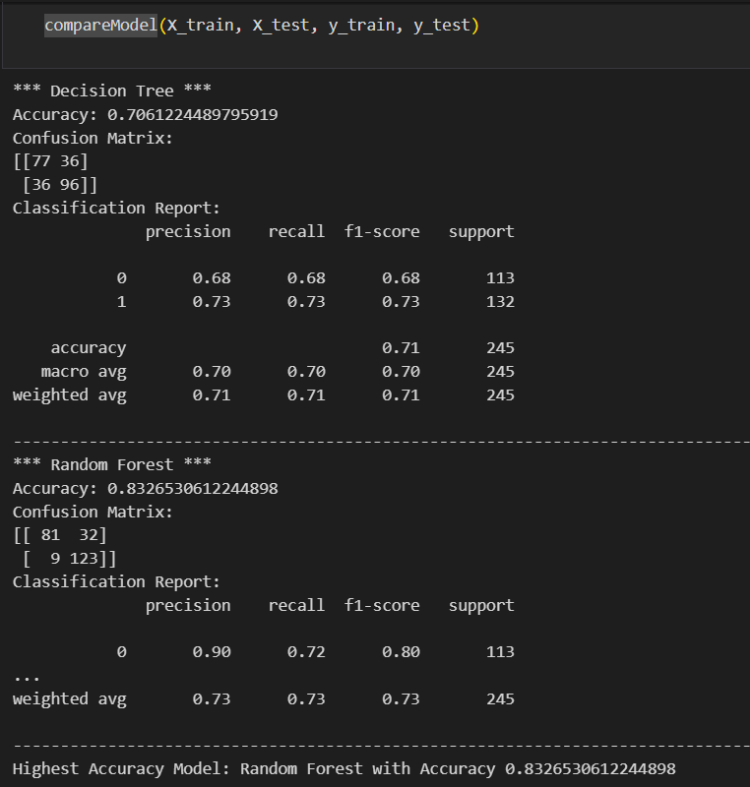

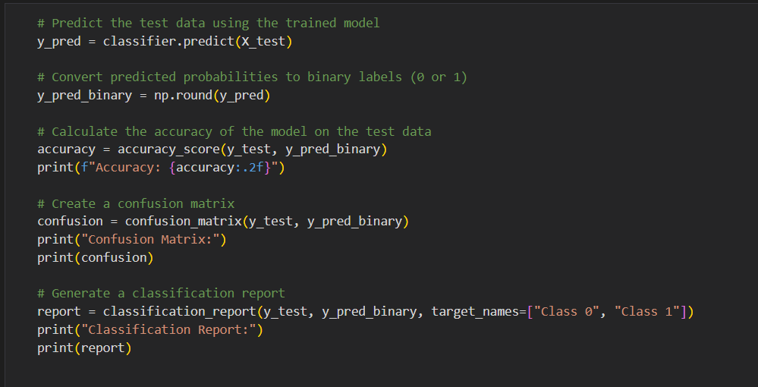

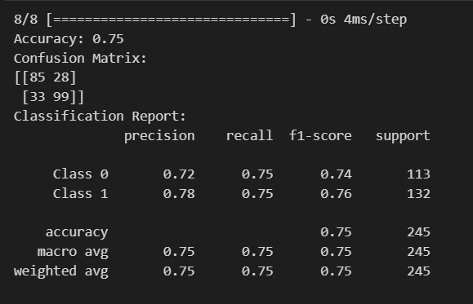

After calling the function, the results of models are displayed as output. From the five models RandomForest is performing well. From the below image, We can see the accuracy of the model. RandomForest is giving the accuracy of 82.85% with training data , 82.2% accuracy for the testing data.

## Activity 2:Comparing model accuracy before & after applying hyperparameter tuning

Evaluating performance of the model From sklearn, cross_val_score is used to evaluate the score of the model. On the parameters, we have given rf (model name), x, y, cv (as 5 folds). Our model is performing well. So, we are saving the model by pickle.dump().

Note: To understand cross validation, refer to this link

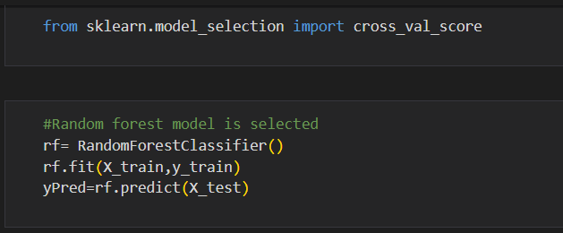

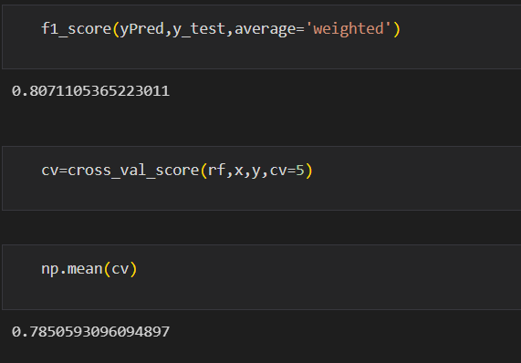

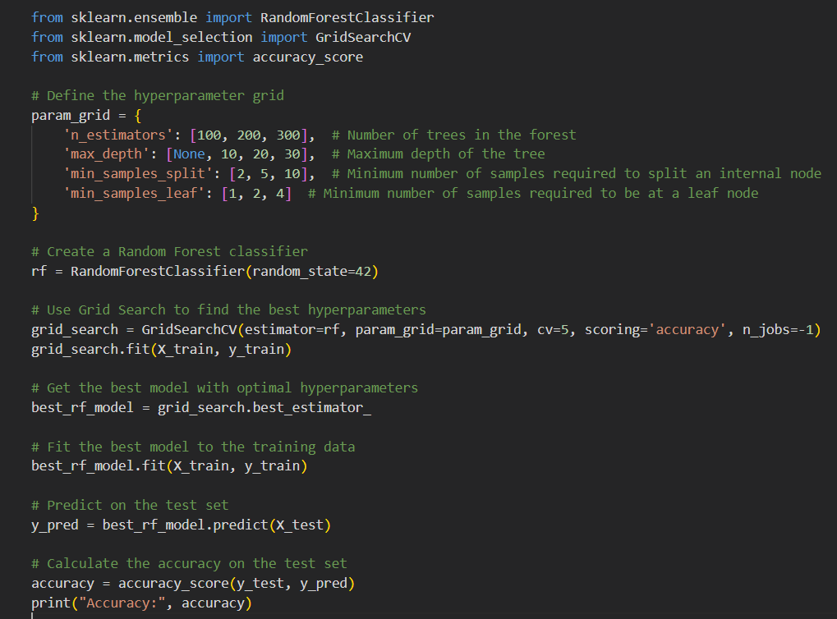



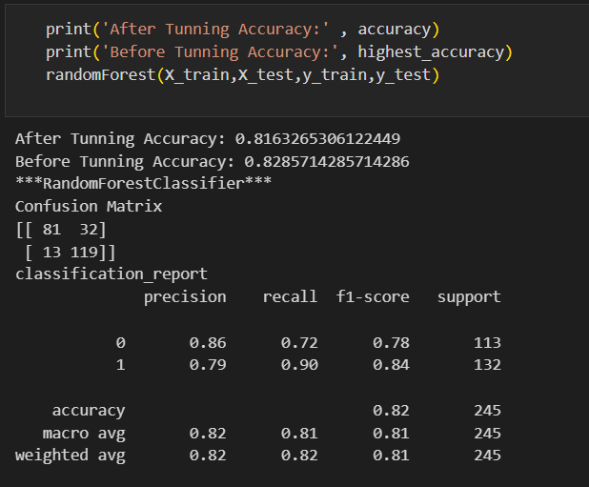

# Milestone 6: Model Deployment

## Activity 1:Save the best model

Saving the best model after comparing its performance using different evaluation metrics means selecting the model with the highest performance and saving its weights and configuration. This can be useful in avoiding the need to retrain the model every time it is needed and also to be able to use it in the future.

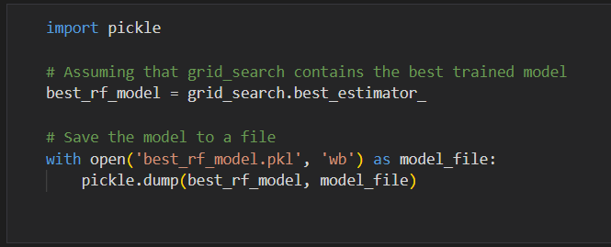

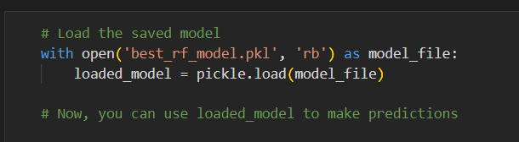

## Activity 2: Integrate with Web Framework

In this section, we will be building a web application that is integrated to the model we built. A UI is provided for the uses where he has to enter the values for predictions. The enter values are given to the saved model and prediction is showcased on the UI.

This section has the following tasks

* Building HTML Pages
* Building server side script
* Run the web application

## Activity 2.1: Building Html Pages:

For this project create two HTML files namely

* home.html
* predict.html

and save them in the templates folder.

**Activity 2.2: Build Python code**:

Import the libraries

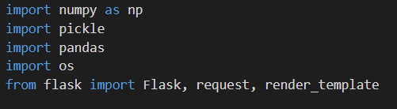

Load the saved model. Importing the flask module in the project is mandatory. An object of Flask class is our WSGI application. Flask constructor takes the name of the current module ( name ) as argument.



Render HTML page:

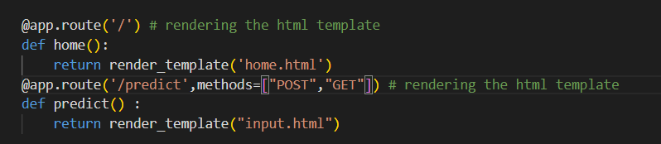

Here we will be using a declared constructor to route to the HTML page which we have created earlier.

In the above example, ‘/’ URL is bound with the home.html function. Hence, when the home page of the web server is opened in the browser, the html page will be rendered. Whenever you enter the values from the html page the values can be retrieved using POST Method.

Retrieves the value from UI:

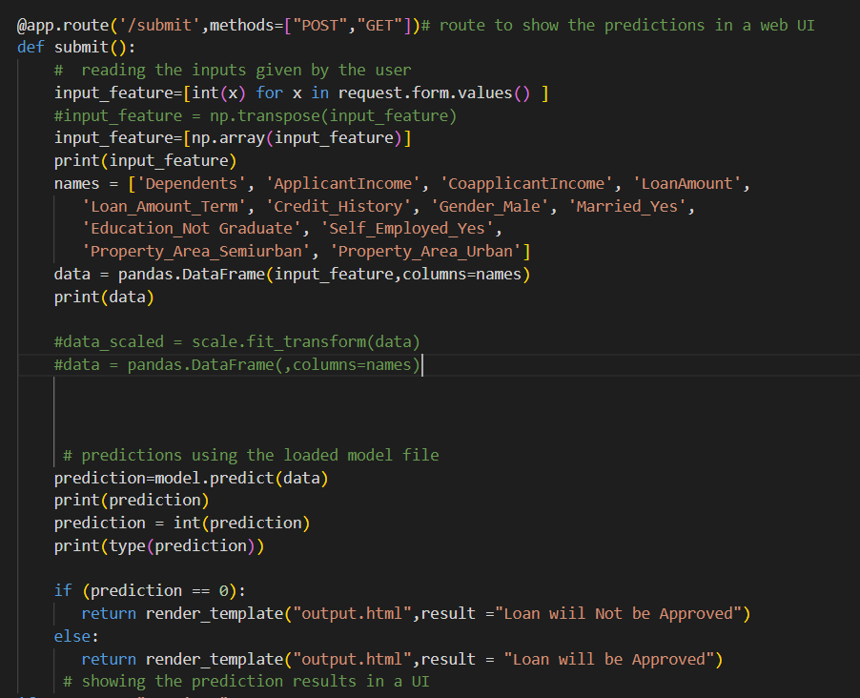

Here we are routing our app to predict() function. This function retrieves all the values from the HTML page using Post request. That is stored in an array. This array is passed to the model.predict() function. This function returns the prediction. And this prediction value will be rendered to the text that we have mentioned in the submit.html page earlier.

Main Function:

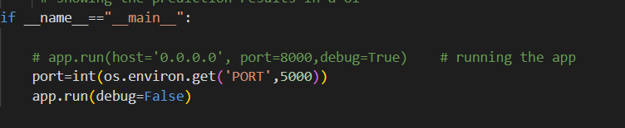

## Activity 2.3: Run the web application

* Open anaconda prompt from the start menu
* Navigate to the folder where your python script is.
* Now type “python app.py” command
* Navigate to the localhost where you can view your web page.
* Click on the predict button from the top left corner, enter the inputs, click on the submit button, and see the result/prediction on the web.



Now,Go the web browser and write the localhost url (http://127.0.0.1:5000) to get the below result.

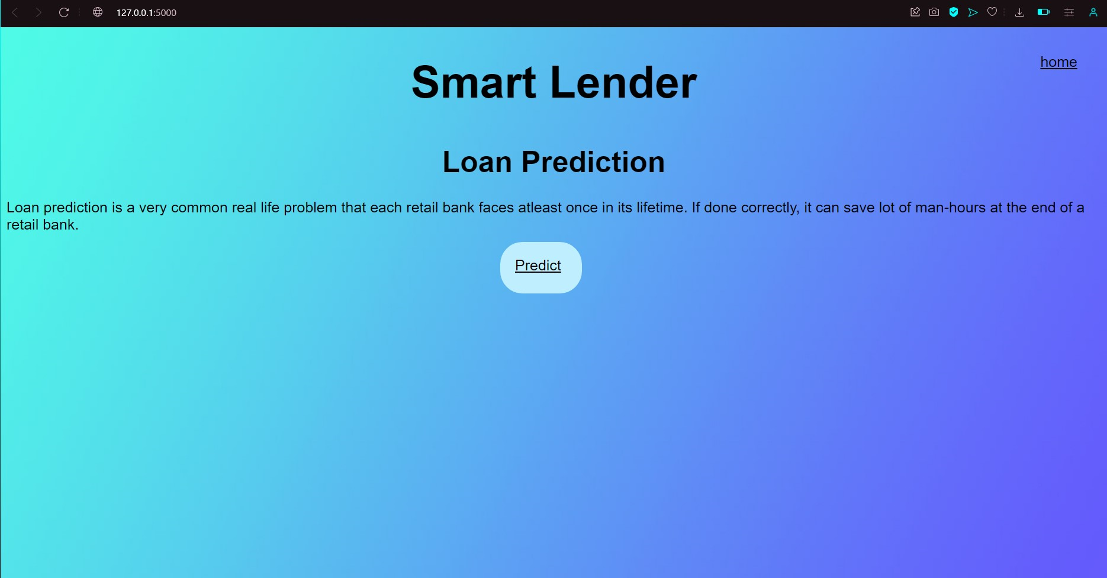

Now,when you click on click me to predict the button from the banner you will get redirected to the prediction page.

Input 1- Now, the user will give inputs to get the predicted result after clicking onto the submit button.

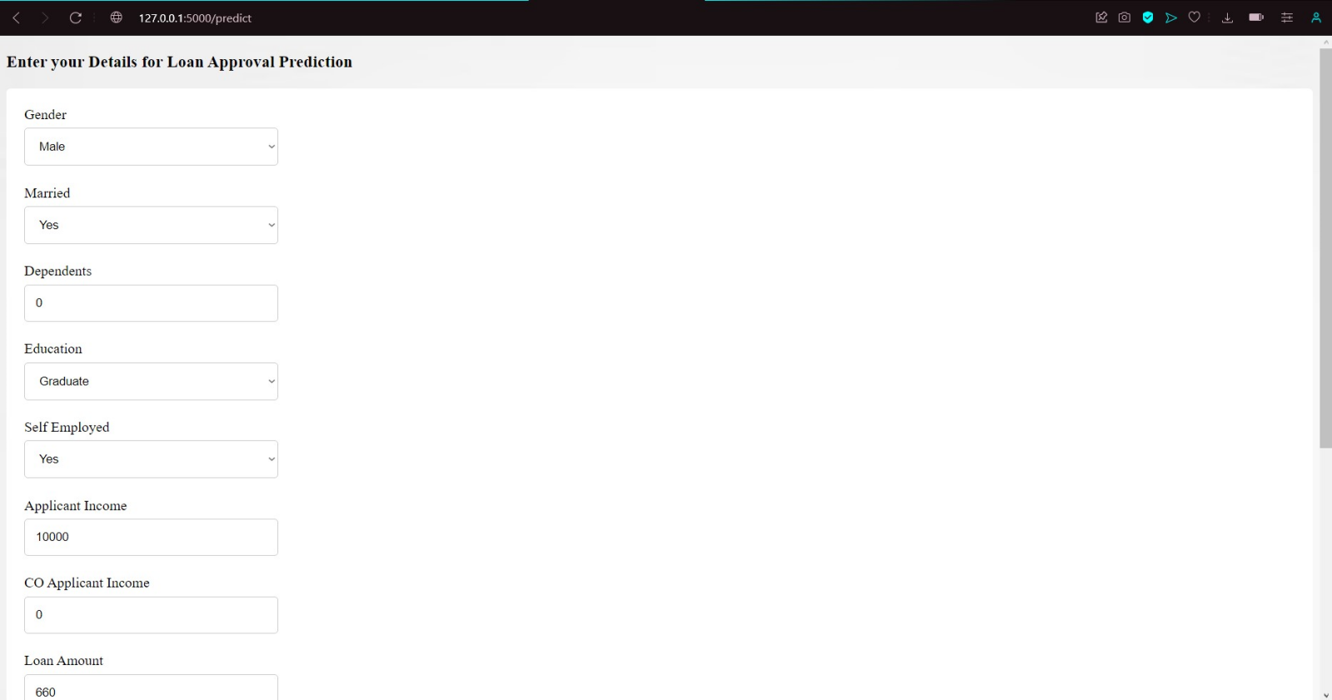

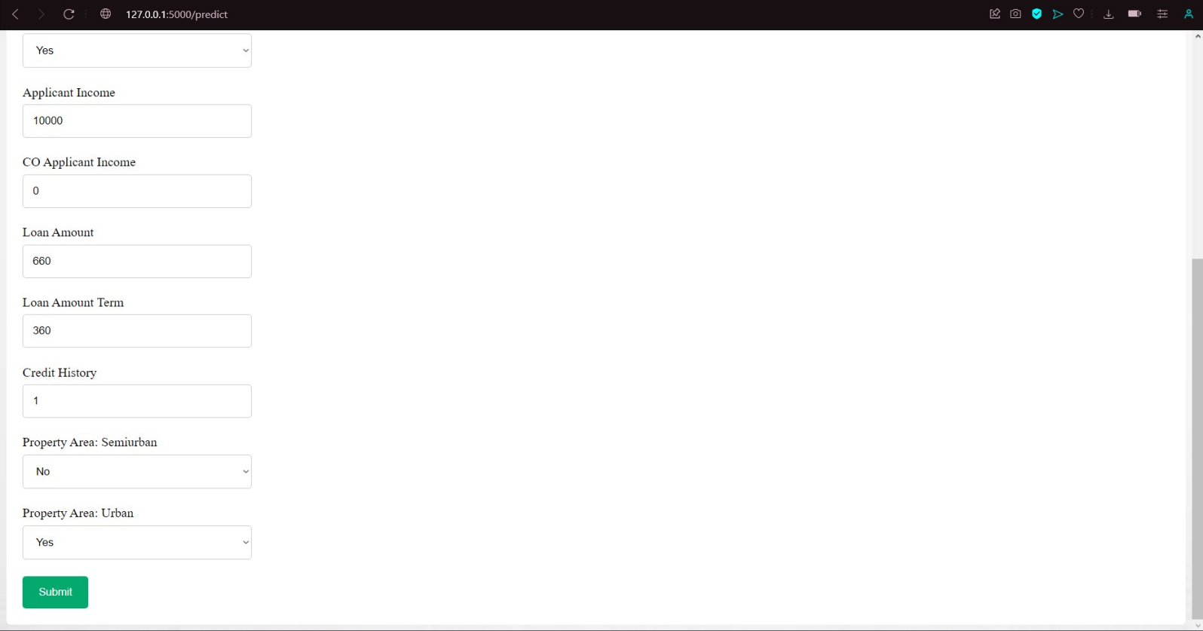

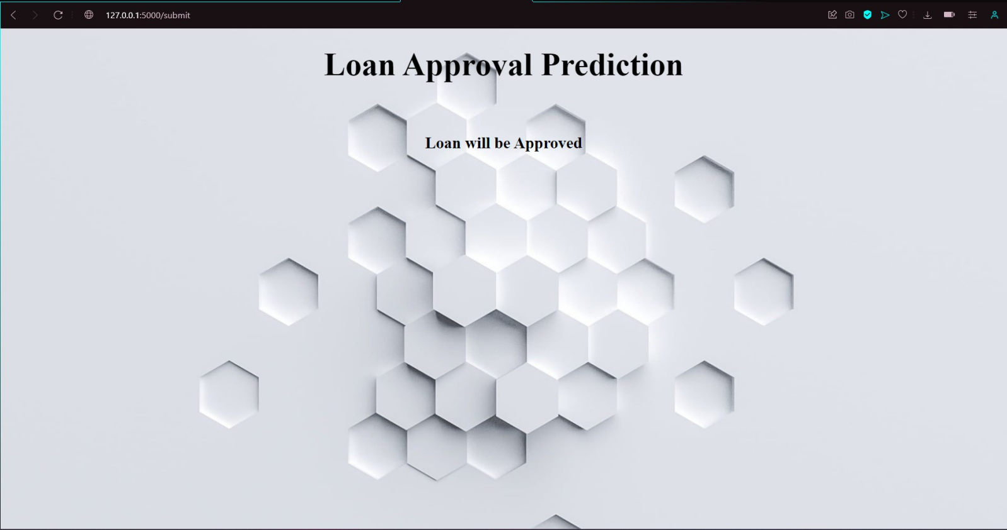

**Milestone 7: Project Demonstration & Documentation**

Below mentioned deliverables to be submitted along with other deliverables

## Activity 1:- Record explanation Video for project end to end solution

**Activity 2:- Project Documentation-Step by step project development procedure**

The project demonstration video is uploaded in the Github.